PRESS RELEASE
February 6th, 2018

“NGO Ba Futuru and OHM help Women to Drive Peace and Economic Development”

Dili, Timor – Leste – NGO Ba Futuru in partnership with Organizasaun Haburas Moris (OHM) will finish the pilot of the Women Driving Peace and Economic Development Project at the end of February 2018. The Project has worked to enhance women’s ability to participate in the economy and mitigate conflict in their lives thus advancing stabilization, peace and recovery. This life-enhancing project was supported by the Canada Fund Local Initiatives.

Peter MacArthur, Ambassador of Canada to Indonesia and Timor-Leste, expressed his support for the project: "Canada is committed to empowering women in all areas of their life and reducing gender-based violence. We are proud to have supported a project that has yielded such positive and tangible results for women in Timor-Leste, and which has given them a voice within their community."

There were significant outcomes from this project including providing life skills and knowledge to enhance women’s capacity in regard to managing their own businesses, identifying required resources and support from other stakeholders, and encouraging women to make decisions regarding household finances. The trainings also empowered women to contribute to conflict resolution, as well as educate them about gender-based violence.

A 43-year-old, head of a women’s group, who participated in the Women’s Economic Empowerment training states “I am pleased with the trainings delivered by dedicated and enthusiastic facilitators from Ba Futuru. The training has provided essential information about running a business, identifying existing resources and how to seek assistance from local organizations to run a business, and gain deeper understanding of budgeting. Before taking part in the training, I did not realize that there are support and resources available to help us start our own business. With the trainings, I can now set my own goals and have my own action plan. I highly recommended that this training will be continued in the future”.

Surveys conducted show that this project has had a significant impact improving the livelihood of participants in the Bobonaro District. Post-training survey shows that after the trainings, 95% of participants felt confident to manage their own business, compared to 63% from the pre-training survey. Before the trainings, only 58% of women reported that they could identify resources and the support required to run a business. This number increased to 100% after the training. The post-training survey also showed that 100% of women now felt confident to make decisions in regard to their family’s economic situation, compared to only 58% beforehand.

Surveys about the conflict resolution and gender-based violence training also showed significant improvement on how participants’ behavior, perception and skills were changed before and after the training. Before the training, only 53% of participants’ stated that they could resolve a conflict. This number increased into 73% after the training. Furthermore, before the training, only 47% of participants agreed that domestic violence was against the law, this number increased to 95% after the training. The post-training survey also showed that 84% of participants agreed that men and women should have equal household responsibility, compared to the pre-training survey that showed only 58% of participants had agreed with this. One participant commented that the training helped them identify conflict around them and in their family, and that it had helped them to resolve the conflicts that arose.

A 22-year-old female participant commented, “I’m grateful to participate in the training. Now, I have a clear understanding about conflict, methods and approaches to resolve a conflict, and the skills to make decisions. Often, we resolve conflict with violence, but now I can resolve conflict in a non-violent way. I look forward to sharing this information with friends and family.”

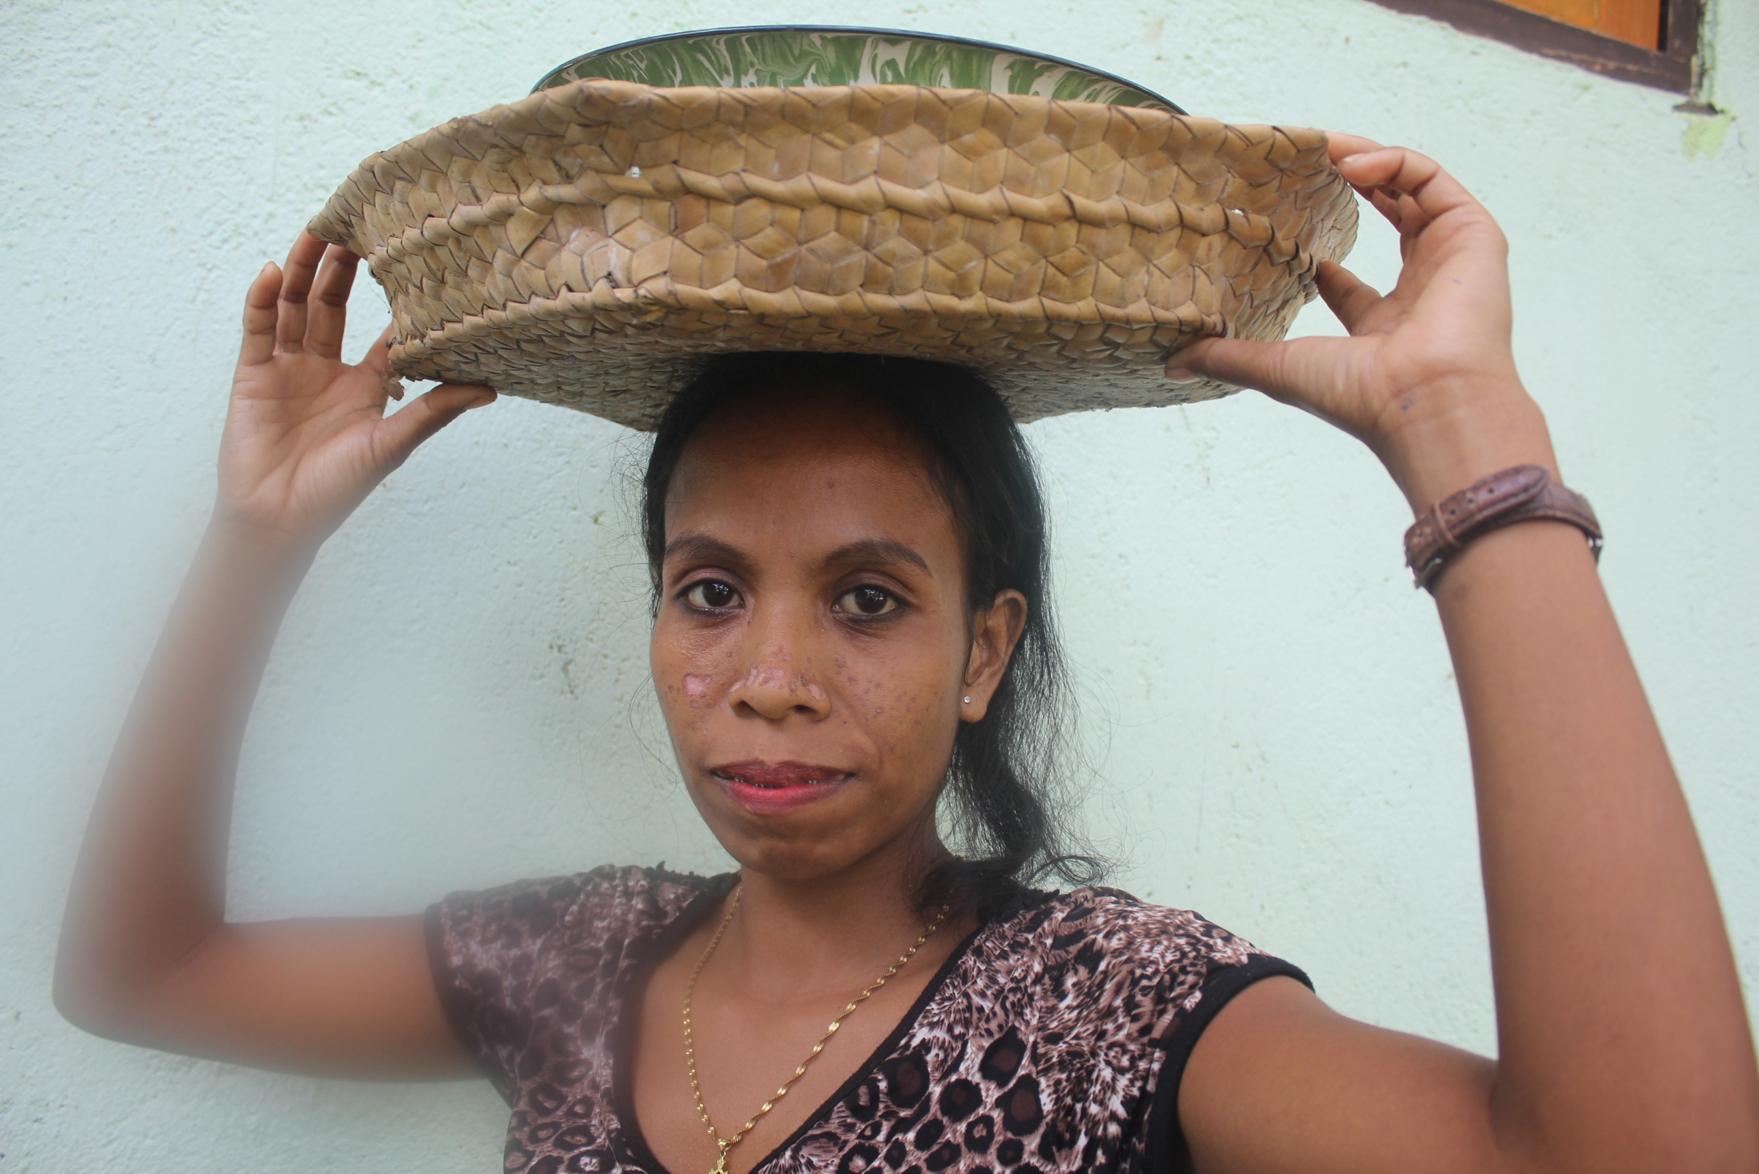
Perhaps, the most successful story of this project is that women now feel empowered to run a business, feel encouraged to take part in conflict resolution, as well as raising their awareness about gender-based violence. Several participants were inspired to seek assistance from local stakeholders to support their small businesses such as opening a clothes alteration shop. Moreover, most participants’ state that they are now more aware of gender-based violence and can better solve conflict within their family and in the community. The majority of participants engaged in the training also demonstrated noticeable changes in their skill level and knowledge in building their own business, and feel inspired to contribute to their community.

Due to this pilot project’s merits and successes, support for delivering a further 3-year version of the project in Bobonaro Municipality and on Atauto Island is being provided by Misereor, the German Catholic Bishops' Organization for Development Cooperation, together with a small grant from the US Embassy in Timor – Leste.

###

